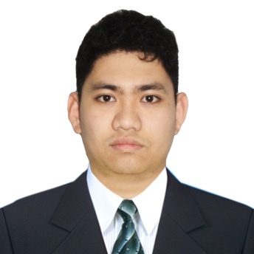

**Hardware and Software Proficiency**

**ALDRIN KEIN G. FRANCISCO**

BS Computer Science

With Specialization in Software Engineering

* Python
* HTML/CSS
* JavaScript
* Java
* C/C++
* C#
* Android
* Matlab / Octave
* PHP
* ASP .NET
* SQL

**Objective**

To Obtain a position in software development where I can utilize my passion and skills in programming and web development to further help the growth and productivity of the company.

**Accomplished Projects**

**Awards**

* + - Rice Diseases Analyzer using Machine Learning for Thesis
    - Manga Scraper And Downloader using C# as a Personal Project
    - Tipping Calculator For Android as a Personal Project
    - Inventory Management For Android as a School Project
    - Hangman Game in C# as a School Project
    - Dog Or Cat Identifier as research for Neural Networks

**Organizations**

**Education**

2013 - present

**BSCS with Specialization in Software Engineering**

FEU Institute of Technology

1. Paredes St., Sampaloc, Manila

2011 - 2013

**BS in Civil Engineering**

FEU Institute of Technology

1. Paredes St., Sampaloc, Manila

**High School**

**Other Interests**

2007 - 2011

University Of Rizal System Morong

Morong, Rizal

Video Games

Playing Instruments

Reading

Baking

**Personal Information**

Address : 535 Capinpin St. Morong Rizal

Mobile : 09982375310

E-mail : akfrancisco22@gmail.com

Birthday : March 22, 1995

Parent : Novencio SJ. Francisco & Lorna G. Francisco

Online Resume Link: https://github.com/aldrin233/My-Information